**SE MODEL OF HEALTH**

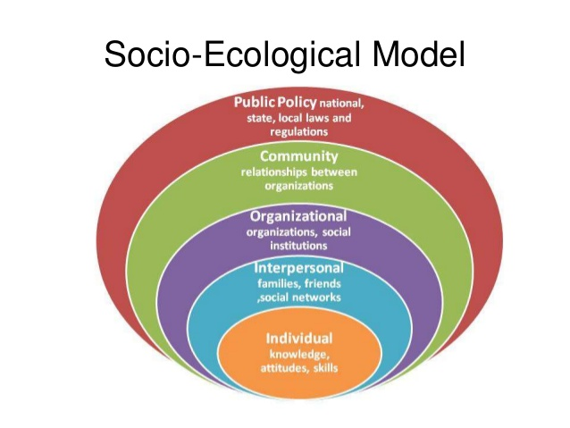

|  |  |  |
| --- | --- | --- |
|  | **Text example** | **Teen body image and social media - Example** |
| Individual | * + Knowledge, attitudes, behaviours, self- concept, skills, developmental history   + How different external factors impact on a person health | * + Psychological disorder as a child   + Personality traits - perfectionism |
| Interpersonal | * + Formal and informal social networks and social support systems- e.g. family, work, friends, partners | * + Habits and values learnt from family members   + Jealousy of friends/ peers   + Verbal abuse from partners etc. |
| Organizational | * + Social institutions and organization characteristics, formal and informal rules and regulations for operators | * + Workplace body image   + Sporting/ fitness organisations |
| Community | * + Relationships among organization, institution and informal networks with defined boundaries | * + School   + Industries (fashion, fitness, beauty) |
| Societal | * + Societal or cultural norms, policies and laws, skill building, outlook on life | * + Society values- social media   + Pressure to look a certain way to be admirable/ visually appealing   + Australian culture- beauty, beachy |

**MASLOWS HIERACHY OF NEEDS**

Maslow's hierarchy focuses on describing the stages of growth in humans. Maslow used the terms "physiological", "safety", "belongingness" and "love", "esteem", "self-actualization", and "self-transcendence" to describe the pattern that human motivations generally move through.

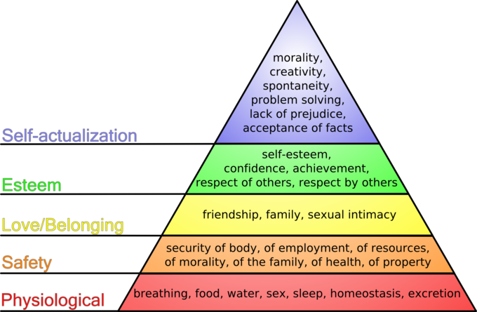

**Safety**

* Once physiological needs are met an individual turns to safety and security in order to be free from the threat of physical and emotional harm
* Fulfilled by: living in a safe area, medical insurance, job security, financial referees
* If a person feels unsafe or threatened, needs further up the pyramid will not receive attention until safety is resolve

**Esteem**

* Achievement, status, responsibility
* After a person feels they belong, the urge of importance emerges
* Social status, accomplishment

**Self- actualization**

* Personal growth and fulfilment
* Truth, justice, wisdom, meaning
* Acceptance and realism, problem, spontaneity, autonomy and solitude, continued freshness of appreciation, peak experiences

**Physiological**

* Needs required to sustain life
* Other needs can't be met without physiological needs
* Air, food, drink, shelter, warmth ,sex, sleep

**Love and belonging**

* Can impact the individuals ability to form and maintain emotionally significant relationships
* Override the name for safety

**SPECIFIC POPULATIONS**

|  |  |  |
| --- | --- | --- |
| **GROUP** | **CHARACTERISTICS** | **NEEDS** |
| Indigenous | * + Socioeconomic- income is 62% of non-indigenous Australians income   + Demographic- 40% of population is under 15 compared to 20% of non-indigenous   + Geographic- 1/4 of indigenous people live in remote areas   + Education- half as likely to graduate school   + Employment- more likely to be unemployed | * + Better access- health care, education and employment   + Improved living conditions- in remote areas: water, sewerage, power, roads, housing etc.   + Diabetes health- 10-30% have the condition 6% seek help   + Social and emotional health- higher levels of psychological disorders   + Cardio-vascular health- 1 in 8 have long term heart or related condition |
| Prison | * + 35% not completed year 10   + Indigenous population- low education   + Repeat offender numbers- high return rate   + Mental health   + Disadvantaged backgrounds   + Drug and alcohol use/ addiction | * + Access health services to treat chronic disease   + Risky behaviours interventions (drug use/ alcohol/ unprotected sex)   + Mental health assessment and action plan   + Services to access once released |
| Rural and remote | * + Higher proportion of disadvantaged families   + 9% of old age people are rural/remote   + More likely to be employed by trade   + 40-59% expect children to get degree | * Better access to health care, education and employment * Substance abuse prevention * Dental health- poorer with tooth loss and untreated decay * Mental health- due to socioeconomically disadvantaged, isolation and lack of services * Cancer prevention- melanoma and lip cancer 60% higher than urban |
| Socioeconomically disadvantaged | * + Socioeconomic- bottom 20% of Australians (disadvantaged)   + Education- more likely to have no non- school qualification   + Employment- unemployed people include socioeconomically disadvantaged | * + Obese or overweight support- 42% are overweight/ obese, more likely to have depression and type 2 diabetes   + Exercise- 45% are sedentary and need to increase their exercise level   + Smoking cessation- 28% smoke daily   + Mental health- 40% of unemployed people experience high psychological stress |

**FACTORS THAT CREATE INEQUITY**

**Gender:** Due to discrimination many women do not experience the same opportunity, support or access to quality social determinants as men. This reduces health status of many women around the world

**Unemployment:** unemployed people are usually low on the social gradient, are usually to some extent socially isolated and experience higher stress levels.

**Occupation:** The type of job a person has and the working conditions he or she is exposed to affects health.

**Education:** higher quality education opportunities tend to be more available for people living in major cities or people who are prepared to pay more for it. Several specific population groups find it harder to remain in education for longer.

**Social isolation:** if people cannot access services and groups and participate in the life of society, their health suffers. They will become isolated.

**Geographic location:** some geographic locations are more difficult to become healthy places. Remote and rural locations are a long way from health services and experience extremes in climate which can be challenging for improved health outcomes.

**Poor health literacy:**

**Dislocation of land:**

**Government policy:**

**Socioeconomic status:**

**Racism:**

**Discrimination:**

**Access to health care:**

**NEEDS ASSESMENT**

**Purpose-**

* Addresses health inequities (prioritise health needs)
* Engages the specific population, allows them to contribute to the plan (empowerment)
* Improves to use of allocated resources

|  |  |  |
| --- | --- | --- |
| **Normative need** | Need that is defined by experts. Normative needs are not absolute and there may be different standards laid down by different experts. | Vaccinations, a decision by a surgeon that a patient needs an operation |
| **Felt need** | Need perceived by an individual. Felt needs are limited by individual perceptions and knowledge of services. | Having a headache, feeling knee pain |
| **Expressed need**(Demanded need) | Felt needs turned into action. Help seeking. | Going to the dentist for a toothache |
| **Comparative need** | Individuals with similar characteristics to those receiving help. | Compiling an at risk registrar of babies in need of specialist treatment based on characteristics which have been associated with handicap in the past |

**NEEDS ASSESMENT STEPS**

Machine generated alternative text:
1, Assessment 
2. Capacity 
3. Planning 
profiling needs and response capacity 
Mobilizing and building needed capacity 
Developing a prevention plan 
Using programs, policies, and strategies 
4. Implementation 
5. Evaluation 
based on what is known to be effective 
Considering program effectiveness and 
sustaining what works well. 

**OTTAWA CHARTER**

|  |  |
| --- | --- |
| **Action Area** | **Definition** |
| Developing Personal Skills | Education is the key aspect of this priority. It refers to gaining knowledge and life skills to make informed decisions that may indirectly effect their health. |
| Creating Supportive Environments | A supportive environment is one that promotes health and assists people in making healthy lifestyle choices. This priority recognizes the impact that broader determinants have on health and aim to promote a healthy physical and social environment or the community to allow people to live healthy lives. |
| Strengthening Community Action | Focuses on building links between individuals and the community working together to achieve a common goal |
| Reorienting Health Services | Refers to reorienting the health system so that it promotes health as opposed to only focusing on diagnosis and treating illness, as is the case with the biomedical model. |
| Building Healthy Public Policy | Relates directly to the decisions made by the government and organizations in relation to laws, regulations and policies that affect/ improve health. |

|  |  |  |
| --- | --- | --- |
| Enable | Mediate | Advocate |
| To make someone able to do or to be something. To give an individual or group the means or opportunities to do something. To empower | To intercede, to act between parties with a view to reconciling. Form a connecting link or stage between two others. | To speak on behalf of another person. To plead for a cause or an idea. To speak, plead, or argue in favor of something. |
| Strategies |  |  |
| * + Improve health literacy   + Career guidance   + Education and training   + Involve them in decision making   + Delegate- give people a role or responsibility   + Access- increase access to health care, welfare, housing, support   + Develop networks- create a supportive environment   + Goal setting   + Improve communication skills   + Counselling   + Mastery- achieve some success | * + Hold meetings- get everyone together to talk about the issue. Open the lines of communication between two parties   + Establish rules or procedures for how things should move forward   + Active listening- listen to each party to find out what they really want or need.   + Empathy- seek to understand them.   + Paraphrase each point of view to increase clarity.   + Ensure that both sides make the decisions and decide on solutions.   + Organize each party to be prepared for meetings- pre meeting preparation.   + Develop a timeline for solution and goals   + Construct a written agreement packages and circulate them to all parties.   + Facilitate agreement on the important issues first. | * + Raise awareness   + Research- get to know the cause or issues really well.   + Hold events   + Hold press conferences or debates   + Notify the media, send press releases, invite them to your events.   + Write to politicians   + Include the people you are advocating for in the process.   + Set goals- be clear about what you want to achieve   + Use a variety of communication techniques- internet, events, newsletters, adverts etc. |

**CULTURAL AND HEALTH**

**Beliefs:**

A belief is an internal feeling that something is true, even though that belief may be unproven or irrational.

**Attitudes:**

An attitude is the way a person expresses or applies their beliefs and values, and is expressed through words and behaviour

**Values:**

A value is a measure of the worth or importance a person attaches to something; our values are often reflected in the way we live our lives.

|  |  |
| --- | --- |
| Major factors that create differences between cultural groups include: | Health care issues arising from cultural differences: |
| * Education level * English language proficiency * Financial resources * Sexual orientation * Geographic location * Adherence to customs and behaviours | * Mistrust of western medicine * What has caused illness * Treatment * Traditional therapies * Role of spirit * Healing customs * Religion and faith * Medication food and diet * Role of elders or cultural leaders |

**Social Network** - A set of links or connections between friends, colleagues, peers, family or other people. Social networks can be maintained by communication with others. Communication can be face to face, or using technology such as phones, internet etc.

**Social Support** - A physical and emotional comfort given to us by our family, friends, co-workers and others. Having a strong, well connected social network will undoubtedly improve social and emotional health. Having people you can talk to, socialize with and turn to for help or advice will increase confidence, self-esteem and wellbeing.

**Norms:** Customs and values which both guide behaviour and act as a framework from which behaviour is judged by the majority.

**Majority norms:** Unwritten rules or standards that more than 50% of the population or community believe in or obey

**Norms of specific groups:** Social or cultural norms that are unique to a particular group of people within a population

**Popular norms:** Norms made by people who are considered popular or who hold power. Popular norms are followed by people who are or want to be perceived as trendy or 'in'

**Proscriptive norms:** Norms that prescribe behaviour, so they make you do something (a behaviour you should do).

**Prescriptive norms:** Norms that prohibit you from doing something (A behaviour you should not do).

**PABCAR**

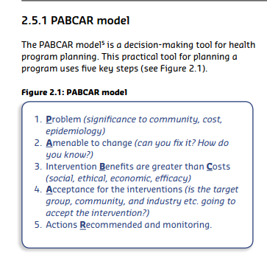

**Problem-** Identify the problem, determine significance of health issue and how it effects the community, research epidemiological data

**Amenable to change**- Investigate other communities- what problems did they face, were they overcome- can solutions be used. Change will depend on community engagement

**Benefits and costs-** Do the benefits of the program outweigh the costs (financial/social/ethical). Will the benefits of the program positively impact the community?

**Acceptance**- Does the community accept program- do they feel the intervention and strategies will be successful.

**Recommendation**- If there is a string of community acceptance, the program can move forward. If not there is a need to raise awareness of the issue.

**HEALTH INQUIRY**

**Planning health inquiry**

* 1. PLANNING- State the purpose of the inquiry

Examples of how to start 'purpose statement'

This inquiry will …….

This inquiry aims to recommend effective preventative strategies for ……..

The purpose of this inquiry is to find out why ….

* Focus Questions (must start with)

Who

What

When

Why

Where

How

Example questions

How can cancer be prevented (poor focus question too vague)

Which primary prevention strategies are best used to prevent cervical cancer in Australia?

(specific, higher order thinking)

* 1. **RESOURCES-** Using a range of information to explore a health issue
* Internet - search engines, data base, .org, .gov, .edu.au (reliable websites)
* Books - journals, encyclopaedias, biography, dictionaries
* Media - newspapers, brochures, flyers
* Interpersonal - interviews, focus groups, surveys
  1. **INTERPRETATION OF INFORMATION**
  2. **PRESENTATION OF FINDINGS**

**HEALTH CARE REFORM**

**AHCRA priorities**

* Consumer/citizen centered system
* Continue closing the gap
* Building primary health care and prevention as the core of the health system
* More effective prevention of ill-health and promotion of well-being by consideration of the social determinants of health
* Creation of a Health Care Waste Commission

**PROGRAMS**

* **Private Health Insurance-** Citizens in Australia with PHI get a percentage of their health insurance paid back by government (amount repaid depends on income). People with PHI don’t access public system thus saving it for people of lower income needing access to public health system
* **Public screening programs-** Government funded. Gives protocols free of charge to target populations for target health issues ( health issues must be easy to detect and treat)
* **Public health vaccination programs-** Government funded immunizations that target specific diseases and populations based on need and infection risk.
* **National Immunization Program Schedule**- child/ infant programs, school programs and special groups for at risk individuals E.g. indigenous people, pregnant women, people with medical conditions, elderly people.
* **Pharmaceutical benefit scheme (PBS)-** Government program that subsidizes medicines and pharmaceutical products for Australian citizens.

**HEALTH LITERACY**

**Functional Health Literacy**

* Set of generic literacy skills applied to the health environment

Skills that allow an individual to

* Read consent forms, medicine labels and health care info
* Understand written and oral information from doctors, nurses or other health professionals
* Keep appointment schedules
* Adhere to self-care at home

**Conceptual Health Literacy**

* Multi-dimensional approach links generic skills with technical and cultural knowledge
* Use health information to make informed choices, reduce health risks, seek out help - improving quality of life

Skills include:

* Science - knowledge of risk, understand scientific terminology
* Culture - awareness of local beliefs and impact on public health
* Civic - understand local government system and health policy
* Technology - ability to web-search and access online information
* Media - understand credibility of an advertisement

**Health Literacy as Empowerment**

* Focuses on the interactive nature of literacy and power

Skills include:

* Understanding rights as a patient and navigating the health care system
* Acting as informed consumers about health risks of products and services
* Understand options in health care providers
* Acting individually or collectively to improve health through the political system - voting, advocacy or social movements

**Link between Health Literacy and Health Status**

* Limited literacy is linked directly with poor health status
* Clear correlation between inadequate health literacy and increased mortality rates
* Limited health literacy can lead to shame and practical difficulties in patients trying to navigate the health system
* Health literacy is fundamental to patient engagement
* If people cannot obtain, process and understand basic health information, they will not be able to look after themselves or make sound health-related decisions.

**People with low health literacy have:**

* Poorer health status
* Higher rates of hospital admission
* Less likely to adhere to prescribed treatments and care plans
* Experience more drug and treatment errors
* Use less preventative services
* Cannot follow complex medical regimes i.e. for chronic or long-term conditions
* Cannot engage in effective self-management
* Lack the knowledge to make informed health decisions
* Do not understand how to access health care when required

**DETERMINANTS OF HEALTH**

The circumstances in which people are born, live, work and age, including systems put in place to deal with illness. These circumstances are in turn shaped by a wider set of forces such as, economic and political dimensions.

|  |  |
| --- | --- |
| **Determinant** | **Example of how it causes inequity in health** |
| Socioeconomic | * + Access to services   + Income   + Housing/ neighbourhood   + Migration/ refugee status   + Education   + Employment   + Family   + Food security   + Geographic location |
| Social | * + Culture   + Social exclusion   + Stress   + Social support   + Transport   + Unemployment   + Work   + Gender   + Addiction   + Social gradient   + Food   + Early life |
| Environmental | * + Natural environment   + Built environment |

**NHPA's**

[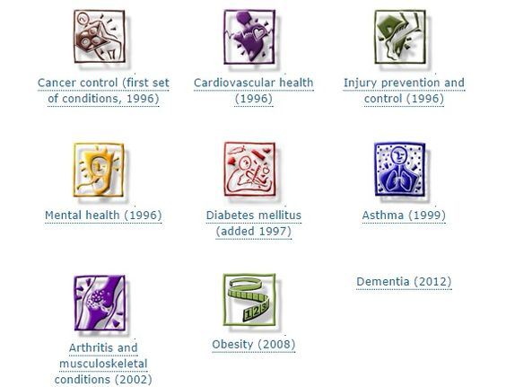](https://www.google.com.au/url?sa=i&rct=j&q=&esrc=s&source=images&cd=&cad=rja&uact=8&ved=0ahUKEwj6ktDngcbOAhVENJQKHbv1DYoQjRwIBw&url=https://www.pinterest.com/pin/165718461264034033/&psig=AFQjCNFbgXXSg9VQn-9YIqnK_cNwj2aaUA&ust=1471439530339490)

**WORLD HEALTH ORGANISATION (WHO)**

The **World Health Organization (WHO)** is a branch of the United Nations concerned primarily with promoting global health. The WHO is made up of over 8000 employees working around the world to improve health.

The WHO works to provide leadership on global health issues and to provide resources and support to countries that require assistance in improving the health of their citizens.

|  |  |
| --- | --- |
| **Agenda** | **Action** |
| * 1. Health Systems | * + Helping countries around the world move towards universal health coverage   + support countries to develop, implement and monitor national health plans   + Supports countries to assure availability of health services at an affordable price |
| * 1. Non-communicable diseases | * + Includes heart disease, stroke, cancer, diabetes, mental health conditions and chronic lung disease   + Responsible for 70% of all deaths worldwide, 8 out of 10 of these deaths occur in low/ middle income countries   + Require more than a system that treats and prevents disease |
| * 1. Communicable diseases | * + Includes HIV, tuberculosis, malaria and neglected tropical diseases (worldwide)   + Increase prevention efforts, reducing vaccine preventable diseases |
| * 1. Promoting health through the life-course | * + Need to address environment risks, social determinants of health, gender, equality and human rights   + Crucial focus on finishing the agenda of millennium development goals and reducing disparities between/ with countries |
| * 1. Preparedness, surveillance and response | * + Leading and coordinating the health response in support of countries during emergencies and coordinating the health response in support of countries   + Undertaking risk assessments, identifying priorities, setting strategies, providing critical technical guidance, supplies financial resources, monitoring health situation   + Help countries strengthen national core capacities for emergencies, prepare response and recovery |
| * 1. Corporate services | * + Provide tools and recourses to make this work possible   + Includes the committees and ambassadors representing member states for policy making, the legal team advising during the development of international treaties, communications staff helping disseminate health information and human recourses providing health experts and building services |

Addressing global health issues and promoting sustainable human development is complex as there are a range of factors that must be addressed to improve living conditions. In order to assist in this process, the WHO’s work is guided by a six-point agenda.

**AUS AID**

The Australian Government contributes to aid programs in a number of ways including:

* Providing funding to international organisations such as the United Nations. This is known as multilateral aid
* Forming bilateral partnerships with developing countries. This is known as bilateral aid.
* Funding NGO's
* Providing humanitarian assistance in times of need - emergency aid.

AusAID plays a leading role in the Asia–Pacific region, particularly in Papua New Guinea and the Pacific. This is even more important given two–thirds of the world’s poor—some 800 million people—live in the Asia Pacific, yet they receive less than one third of global aid. Australia also provides assistance to Africa, the Middle East, Latin America and the Caribbean. Our aid to Africa has increased significantly in recent years and now represents around five per cent of the aid program.

**Aid -** Help, a source of assistance. This could include financial support or practical assistance such as advice, resources, materials or manpower

**Bilateral Aid -** Aid from a single donor country to a single recipient country

**Multilateral Aid -** Aid provided by a group of countries, or an institution representing a group of countries

**NGO's -** Assistance provided by non-government organisations like World Vision, The Red Cross, and Oxfam.

**Emergency Aid-** Providing assistance in time of need

**SUSTAINABLE DEVELOPMENT GOALS**

* **Zero Hunger-** End hunger, achieve food security and improved nutrition and promote sustainable agriculture
* **Good health and wellbeing-** Ensure healthy lives and promote well-being for all at all ages
* **Quality education-** Ensure inclusive and equitable quality education and promote lifelong learning opportunities for all
* **Gender equality-** Achieve gender equality and empower all women and girls
* **Clean water and sanitation-** Ensure availability and sustainable management of water and sanitation for all

**SOCIAL JUSTICE PRINCIPLES**

**Equity-** Fairness, consistency, inclusivity and justice for all people. The opposite of equity is inequity which refers to unfair or unjust treatment, policy or practice.

**Access-** The ability to obtain or make use of a service or product

**Diversity-** Societies or groups with members who have identifiable differences in their cultural backgrounds or lifestyles.

**Supportive environments-**

**ADVOCACY**

* The active support of an idea or cause, in particular the act of pleading or arguing for something. The act of arguing in favour of or the practice of supporting someone to make their voice heard.

|  |  |
| --- | --- |
| **Lobbying** | * + Act of attempting to influence policy   + Attempt to influence government officials   **Examples**: Visiting politicians, writing letters to newspapers, politicians and local members of parliament, media release |
| **Mobilising groups** | * + People uniting to make a difference and influence decision making   Examples: Use social networking to form an action group, create an action group to raise awareness ,  Send action group to advocate issue |
| **Raising awareness** | * + Increasing peoples knowledge or perception of a situation/ health issue through education, health literacy, and changing BVA's   Examples: Health education classes, Social media sites, hashtags/merchandise, posters/ blogs/pamphlets/ flyers |
| **Framing issues** | * + Presenting ideas in a particular way to illicit a desired response (gain agreement)   Examples: Approach media (TV, newspapers, radio) to run stories highlighting health issue, Approach politicians with personal accounts, social media- share stories |
| **Champions** | * + Engaging high profile influential people to promote awareness (raise profile) of a health issue   Examples: Celebrities- the face of the issue (link with issue personally), high profile personalities |
| **Influencing policy** | * + Work aimed at changing policy often involves increasing profile in community   Examples: Join communities and boards, Present politicians with data/ research, work with researchers/ organisations to achieve changes |

**POSITIVE HEALTH SKILLS**

**Assertion**- To communicate ones opinions, needs and emotions while respecting the rights of others

**Resilience-** The positive capacity of people to cope with stress and catastrophe.

**Stress management**- A set of techniques used to help an individual cope more effectively with difficult situations in order to feel better emotionally, improve behavioural skills and enhance feelings of control.

**Supportive environments**- Places that allow people to live, work and play while protecting them from threats to health and increasing their health literacy.

**INTERPERSONAL SKILLS**

|  |  |
| --- | --- |
| **Collaboration skill** | **Definition** |
| Collaborate | Resolving disputes by working together towards a common goal. |
| Negotiate | Achieving agreement through discussion, used to resolve disputes. Negotiators bargain for individual or collective advantage. |
| Mediate | Negotiating to resolve differences by using some impartial party. Intervening for the purpose of bringing about a settlement. The goal is for disputing parties to resolve the conflict themselves with the support of the mediator. |
| Arbitrate | Two or more parties use a third party in order to resolve a dispute. The third party makes the decision for the disputing parties. |
| Leadership | Social influence in which one person can enlist the aid and support of others in the accomplishment of a common task. |
| Facilitation | Making something easy or easier. Assisting or making the process of improving something easier. |
| Compromise | A middle way between to extremes. Finding agreement through communication, a mutual acceptance of terms, often involving variations from an original goal. |

Conflicts:

* **Intrapersonal**- Conflict within the individual.
* **Interpersonal**- Conflict among two or more individuals
* **Intragroup-** Conflict within a a group
* **Intergroup-** Conflict between two or more groups

**GLOBAL HEALTH ISSUES**

**Global/ Local barriers**

* Poverty/ famine
* Disease outbreaks
* Drought
* Availability of clean drinking water

**World Events (That can impact on identity formation)**

* Displacement from traditional homelands
* War, violence and conflict
* National pride
* Natural disasters

**EPEDEMIOLOGY**

* **Life Expectancy-** how long a person is expected to live on average.
* **Mortality-** Number of people dying in a population

- Age specific mortality rates

- Infant mortality

- Cause specific death rates

- Maternal mortality rate

* **Morbidity-** Measures incidence and prevalence of disease in a population

|  |  |
| --- | --- |
| Key Term | Definition |
| **R0** | A mathematical term indicating how contagious an infectious disease is (also referred to as reproduction number)  If  R0 is more than 1 the disease will spread between people and there may be an outbreak or epidemic  If  R0 is less than 1 the disease will decline and eventually die out  If  R0 is equal to 1 the disease will stay alive but there will be no outbreak or epidemic |
| **R nought value only applies when everyone in the population is completely vulnerable** | This means:   * + No one has been vaccinated   + No one has had the disease before and become immune   + There is no way to control the spread of the disease |
| **Infectious period** | The longer the infectious period of a disease, the more likely an infected person is to spread the disease to others |
| **Behavioural change** | Minimizing behaviours in the population that spread disease and/or maximise prevention behaviours |
| **Treatment** | Working out how to best treat the disease, help people recover quicker or become less contagious quicker |
| **Vaccination** | Reduces the need for widespread quarantine as more of the population become immune |
| **Social network** | A high contact rate will contribute to a higher R0 value |
| **Treatment** | Methods of controlling disease outbreak |
| **Contact tracing** | A method used by epidemiologists to trace a disease and work out its origin |
| **Modes of transmission** | * + Through the air   + Bodily fluids   Fomite |
| **Quarantine** | Keeping sick people away from healthy people |
| **Disease control** | Keeping sick people away from healthy people |